GB003834 Alling et al., Non-conservative behavior of dissolved organic carbon across the Laptev and East Siberian Seas

Auxiliary Information for paper GB003834
δ¹⁸O corrections for effects of ice formation and melting
115 samples out of 216 that have been measured for DOC concentrations have also been measured for δ¹⁸O signatures. Based on the salinity and the δ¹⁸O signatures, the effect of ice melting or ice formation and export has been calculated and the salinity, DOC and HS has been corrected to exclude this effect (fig S1). In general, the only resolvable effect is that of ice export and brine formation, which have caused a small increase in the concentrations in the non-corrected data. Most importantly, the main conclusion of this study, the “non-conservative behavior of DOC over the ESAS” is not biased by the melting of sea ice.

The δ¹⁸O signatures vary in the Lena River depending on season, between -17.5‰ to 23.5‰ (PARTNER dataset, Cooper et al., 2008). The River endmember values are though not well constrained, as this study does not have δ¹⁸O measurements of Lena water. It might be assumed that the δ¹⁸O signature varies a lot during the time period from which the inner estuary freshwaters originate from. This is obvious from the data that after correction show negative salinities (even though only a small change in the assumed river signature will give the opposite effect), and the waters below salinity of 8 is regarded to only reflect the variation in the river endmember value, not effects from ice processes. This assumption is strengthened by that fact that the DOC and HS concentrations, without δ¹⁸O corrections, for the inner surface plume correlate very well with conservative mixing of the Lena River water, that has been measured for these parameters in this study (n=3).
In the samples with salinities above 8, the effects of brine formation and ice export are less than 10%, except in the high salinity samples in the Laptev Sea. Those samples have been corrected for brine formation also in figure 5 in the article. All other samples are shown as original uncorrected measurements in the article.
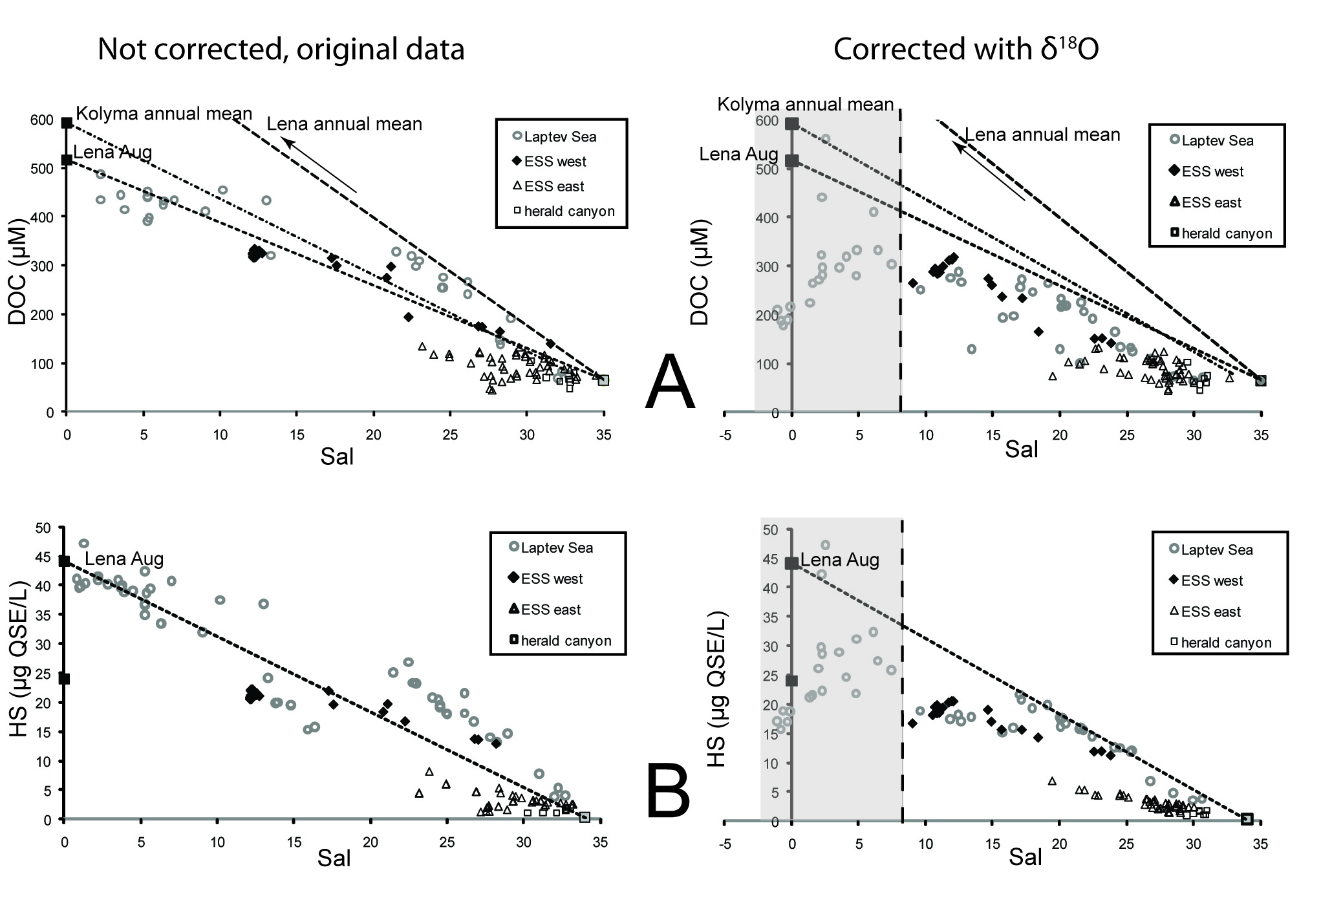 Fig S1 A) The uncorrected and the corrected DOC vs salinity plots. B) The uncorrected and the corrected HS vs salinity plots. Grey areas in the corrected plots show the samples where the δ¹⁸O signatures only reflect the variation in the Lena River, and the effects of ice processes are not possible to estimate from the δ¹⁸O signatures.

Box modelling of residence times and
A general box model was used to obtain first order removal rate constants for DOC, as along with residence times for water and DOC, for the Eastern Siberian Arctic Shelf (ESAS), as well as separately for the western part of the East Siberian Sea (W. of 160°E). The model incorporates inflow of riverine freshwater and DOC as well as the inflow of seawater and DOC from outside the box and the export of water, freshwater and DOC from the box (figure S2). The waters on the ESAS are not well mixed and these calculations therefore distinguish between outflow water properties and mean water properties.

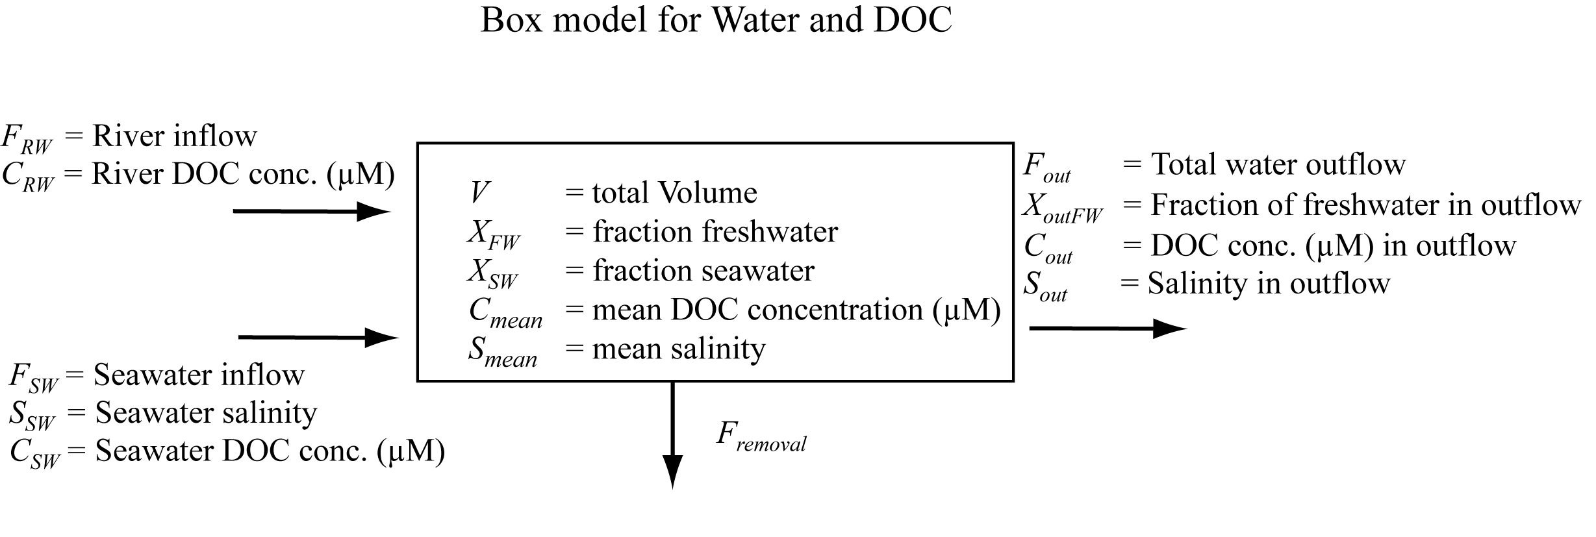
Fig. S2

It is assumed that
- The amount of water in the box is fixed
- The concentrations of salt and DOC are constant (the box is in steady state)
- The fluxes of water, salt, and DOC are constant.
The second and third assumptions are satisfied if volume-weighted mean values are used and variations occur over timescales shorter than the residence times.

Total water balance.
Equating inputs and outputs,
$F_{\text{RW}}+F_{\text{SW}}=F_{\text{out}}$ (1)
The residence time for total water is:
$τ_{\text{water}}=\frac{V}{F_{\text{out}}}=\frac{V}{F_{\text{RW}}+F_{\text{SW}}}$ (2)
A value cannot be obtained for the residence time of water without values for F_{out} and F_{SW,} which are not readily constrained from available observations.

Salt balance
Equating inputs and outputs,
$F_{\text{SW}}×S_{\text{SW}}=F_{\text{out}}×S_{\text{out}}$ (3)
Combining this with (1) and rearranging,
$F_{\text{SW}}=F_{\text{RW}}\frac{S_{\text{Out}}}{S_{\text{SW}}−S_{\text{Out}}}$ (4)
Since F_{RW} is known, this is useful for constraining F_{SW} from salinities (though S_{SW}, the salinity of the seawater input into the box, is not tightly constrained; see below).
Salinities can be related to freshwater fractions by:
$S_{\text{mean}}=S_{0}×X_{\text{FW}}−S_{\text{SW}}×X_{\text{SW}}$ (5)
$X_{\text{SW}}=\frac{S_{\text{mean}}}{S_{\text{sw}}}$ (6)
Since X_{FW} + X_{SW} =1
$X_{\text{FW}}=1−\frac{S_{\text{mean}}}{S_{\text{sw}}}=\frac{S_{\text{sw}}−S_{\text{mean}}}{S_{\text{sw}}}$ (7)
Similarly, for the outflow,
$X_{\text{outFW}}=1−\frac{S_{\text{Out}}}{S_{\text{sw}}}=\frac{S_{\text{sw}}−S_{\text{Out}}}{S_{\text{sw}}}$ (8)
Combining these equations,
$\frac{X_{\text{FW}}}{X_{\text{OutFW}}}=\frac{S_{\text{SW}}−S_{\text{Mean}}}{S_{\text{SW}}}\frac{S_{\text{SW}}}{S_{\text{SW}}−S_{\text{Out}}}=\frac{S_{\text{SW}}−S_{\text{Mean}}}{S_{\text{SW}}−S_{\text{Out}}}$ (9)
This ratio accounts for the difference between the mean composition of the reservoir and the composition of outflowing water, i.e. that the reservoir is not well mixed, and so will affect the calculated residence times (see below). It is often assumed in such models that the box is well-mixed, so that the outflowing water has the same salinity (and other concentrations) as the water in the box, and so X_{FW} = X_{outFW}. However, here it appears that X_{FW}>X_{outFW}, that is, the average salinity of waters leaving the shelf (i.e. along the shelf break) is higher than the volume-weighted average within the shelf. This undoubtedly can be explained by different residence times between the upper layer and deeper waters (and between near-shore and outer waters), which could be captured in a model with a number of boxes, but this would require detailed flow information, which is not available.

Freshwater balance
Equating inputs and outputs,
$F_{\text{RW}}=F_{\text{out}}×X_{\text{outFW}}$ (10)
The residence time for freshwater is:
$τ_{\text{FW}}=\frac{V X_{\text{FW}}}{F_{\text{RW}}}=\frac{V X_{\text{FW}}}{F_{\text{out}}X_{\text{outFW}}}$ (11)
Since VX_{FW} is obtained from the data (X_{FW}=weighted mean value, and VX_{FW} is the total integrated budget for freshwater across the shelf obtained using the interpolation program), and F_{RW} is the river inflows taken from the literature, a value for the residence time of freshwater is obtained if S_{sw} is known, (see eqn 7).
Substituting τ_{water} = V/F_{Out} (eqn 2),
$τ_{\text{FW}}=τ_{\text{water}}\frac{ X_{\text{FW}}}{X_{\text{outFW}}}$ (12)
A value for the freshwater residence time of water can only be obtained if X_{FW}/X_{outFW} is known, calculated using the salinities, as in eqn 9, above.

In the ESAS, S_{mean} = 29, and if S_{sw} is assumed to be 35, X_{FW} is 0.17. This gives a freshwater residence time of 12 yrs. In the western East Siberian Sea, S_{mean} is 24, and X_{FW} becomes 0.31, which yields a freshwater residence time of 4 yrs. However, the inflowing waters might have a much lower salinity than 35.
If, instead, it is assumed that τ_{FW} is 3.5yrs [Schlosser et al., 1994], then solving eqn. 11 for X_{FW}, values of X_{FW} of 0.04 (ESAS) and 0.25 (western East Siberian Sea) are obtained. That requires a S_{sw} of 30.2 and 32.0 for the ESAS and western East Siberian Sea, respectively (eqn 7). The difference between S_{sw} and S_{out} could not be more than 1.3 (eqn. 8 and 9). However, we have salinities that exceed 32 in both Laptev and East Siberian Sea, so that the salinities of inflowing waters in some areas must be considerable higher. Therefore, the mean values used to calculate the residence times are higher and the resulting residence time is somewhat higher than the value of Schlosser et al. [1994]. The τ_{FW} is therefore not well constrained in the total ESAS, but better constrained in the western East Siberian Sea, where the residence time calculated here corresponds better to previous estimates [Schlosser et al., 1994]. If using S_{sw} salinities between the reasonable numbers 32-34 for the western East Siberian Sea, a τ_{FW} of 3.5±1.5 years is received.

DOC balance
The removal of DOC (by degradation, sedimentation, etc- everything except export to the central Arctic) is assumed to be first-order; i.e. the rate of removal is proportional to the amount in the reservoir, so that
$F_{\text{Re}\text{moval}}=\frac{d\left(\text{DOC}\right)}{\text{dt}}=λ{\text{VC}}_{\text{mean}}$ (13)
where λ is the rate constant and (DOC) is the total budget of DOC in the box.
Equating inputs and outputs,
$F_{\text{RW}}C_{\text{RW}}+F_{\text{SW}}C_{\text{SW}}=λ{\text{VC}}_{\text{mean}}+F_{\text{out}}C_{\text{out}}$ (14)
The residence time of DOC is:
$τ_{\text{DOC}}=\frac{V C_{\text{mean}}}{F_{\text{Out}}C_{\text{Out}}+λ{\text{VC}}_{\text{mean}}}=\frac{V C_{\text{mean}}}{F_{\text{rw}}C_{\text{rw}}+F_{\text{sw}}C_{\text{sw}}}$ (15)
Note that there are measured values for all parameters in the second ratio on the right hand side, except F_{SW}, which can be obtained from salinities (eqn 4).
The $τ_{\text{DOC}}$ in the ESAS, calculated from the second term in eqn 15 is 9 years, assuming inflow waters with salinity and DOC concentrations of 35 and 66µM respectively (F_{sw} from eqn 4, C_{sw} from Opsahl et al. [1999]). However, if the S_{sw} is substantially lower, as derived from the $τ_{\text{FW}}$from Schlosser et al. [1994], as described above, $τ_{\text{DOC}}$will be 3±1 years. The variance is depending on the C_{sw} chosen (tested for 70-100 µM).
For the western East Siberian Sea, the residence times for DOC as well as for freshwater is not so sensitive to the value of S_{sw} chosen, and $τ_{\text{DOC}}$is constrained to 2.5±1.7 years.

An expression for λ can be obtained by rearranging equation 15;
$\frac{1}{τ_{\text{DOC}}}=\frac{F_{\text{Out}}C_{\text{Out}}}{V C_{\text{mean}}}+\frac{λ{\text{VC}}_{\text{mean}}}{V C_{\text{mean}}}$ (16)
and then substituting τ_{water} = V/F_{out} (eqn. 2) and simplifying,
$λ=\frac{1}{τ_{\text{DOC}}}−\frac{C_{\text{Out}}}{τ_{\text{water}}}\frac{1}{ C_{\text{mean}}}$ (17)
If the box is well mixed, $τ_{\text{DOC}}$and$τ_{\text{water}}$ alone can determine the removal rate constant. In the case for the ESAS, where the box is not well mixed, the concentration ratio between the outgoing water and the mean water in the box must be known.

An equation for λ could also be derived by combining equation (14), (1) and (4), and rearranging to:
$λ=\frac{F_{\text{RW}}\left[\left(C_{\text{RW}}−C_{\text{out}}\right)+S_{\text{out}}\frac{\left(C_{\text{SW}}−C_{\text{out}}\right)}{\left(S_{\text{SW}}−S_{\text{out}}\right)}\right]}{V C_{\text{mean}}}$ (18)

Therefore, this equation can be used to obtain the removal rate constant. For the total ESAS as well as for the East Siberian Sea W. of 160°E, the values needed for the calculation were obtained from:
V and C_{mean} - data from the DAS program (values for both total ESAS and East Siberian Sea W. of 160°E available in table 1).
F_{RW} and C_{RW} -the total discharge rates and DOC concentrations for water from the Lena, Indigirka and Kolyma Rivers, obtained from the literature [Cooper et al., 2008; Gordeev et al., 1996]
C_{out} -must be obtained from the data for the interpolated concentrations on the shelf break. Some judgement is required to determine where the boundary is, and where there is outflow rather than inflow, but this value is not very sensitive to these decisions, since the boundaries are all away from where there are steep concentration gradients. Mean values around the shelf break for the entire ESAS, as well as for the East Siberian Sea W. of 160°E, give C_{out} concentrations of 80-88µM, i.e. an order of magnitude smaller than C_{RW}.
S_{out} -obtained in the same way as C_{out} with similar uncertainty. Salinities around the shelf break for the entire ESAS, as well as for East Siberian Sea W. of 160°E, varies between 29 and 32.
$\frac{\left(C_{\text{SW}}−C_{\text{out}}\right)}{\left(S_{\text{SW}}−S_{\text{out}}\right)}$ -The values for the waters flowing out of the box must lie on the mixing lines shown in Figs. 7A and 7B, or below these lines where removal of DOC occurs. This ratio is equivalent to the slope of the line for such mixing relationships in a DOC vs. Salinity plot, and so can be constrained from the plot. Estimates of the slope from both Fig.7A and 7D for samples with salinities of 29-35 give an approximate value of -4.5. The steepest possible slope is for the whole dataset, which is -13 (Fig. 4A). However, that does not catch the removals of DOC that clearly have happened before reaching the high salinity areas at the shelf break of any part of the ESAS, and the actual slope for the high salinity samples at the shelf break must be much closer to -4.5 than to -13.

Using these numbers, the term $S_{\text{out}}\frac{\left(C_{\text{SW}}−C_{\text{out}}\right)}{\left(S_{\text{SW}}−S_{\text{out}}\right)}$ varies between -420 (for a slope of -13) and -120 (for a slope of -4.5), and is substantially lower than $\left(C_{\text{RW}}−C_{\text{out}}\right)$ (approximately around 700 for all areas). Consequently λ does not vary more than with a factor of 2, despite the uncertainties.

This gives values for λ for the entire ESAS of 0.05 yr⁻¹ (0.03 if steepest slope is used as value for $\frac{\left(C_{\text{SW}}−C_{\text{out}}\right)}{\left(S_{\text{SW}}−S_{\text{out}}\right)}$).
For the East Siberian Sea W. of 160°E, λ = 0.3 yr⁻¹. This is the area with best total coverage and with a residence time that exceeds the time scale over which removal processes occur. This number is the best estimate of the removal rate constant from this study, as it is not biased by the more limited coverage in the western Laptev Sea or the uncertain inflows in the Laptev and East Siberian Sea E. of 160°E.

